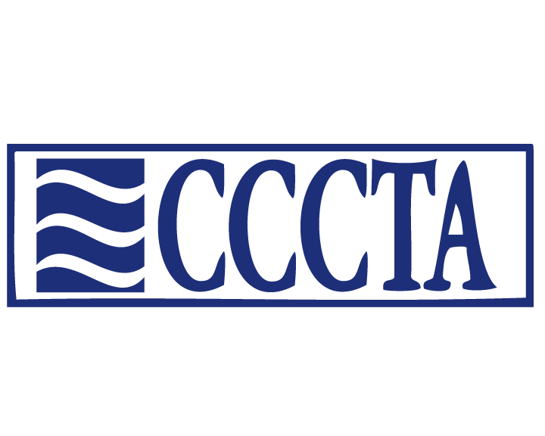

Negotiated Agreement Updates
2016-2018
The CCCTA Negotiations Team bargained with the Board of Education Negotiations Team and agreed to the following changes which were ratified by a member vote last year. Below are highlights of the major changes and improvements.
The Negotiated Agreement is in effect from July 1, 2016 through June 30, 2019.
All unit members should have received a new printed copy of the negotiated agreement.
Concerning Student Behavior
If the student's disruptive behavior results in suspension, expulsion or any action less than suspension, the principal shall confer with the teacher who referred the student to the principal before returning the student to that teacher's classroom (COMAR 13A.08.01. 11). COMAR defines "confer" as a discussion or dialogue by any means, for example, telephone electronic mail, or a face-to- face meeting where the views of the teacher are communicated and considered.
Any unit member who has been threatened with physical abuse, death threats or been abused physically in connection with his/her employment shall immediately report the incident to the school administrator or immediate supervisor and complete an Incident Report. Serious incidents involving verbal abuse or outright disrespect shall be reported in a similar manner.

Additional EPED Positions:
Assistant Cheerleading Coach, Assistant Cross Country, and Lead School Psychologist

Increased Pay Rates:
Home/Hospital Teacher - $30 - $40 After School Teacher - $30 - $40
Summer School Teacher - $30 - $40 Workshop Attendee - $120 - $180
Curriculum Writing,-Teacher - $135 - $200 Workshop Presenter-Teacher - $150 - $220
Security Games Management - $36 - $50 Games Clock Operator - $43 - $50

Tuition Reimbursement Increases
The Board shall reimburse a unit member up to $249 to $483 per credit hour, not to exceed maximum in any one calendar year of $1494 to $4347 provided the amount of reimbursement shall not exceed the annual cost for tuition.

A unit member who completes a professional development course with Continuing Professional Development (CPD) credits offered through the Maryland State Department of Education (MSDE) or an accredited educational institution shall be eligible for reimbursement.

Advanced Preparation Payments
Masters or APC from $1775 to $1975
Masters and APC from $2525 to $2800
Masters plus 30 from $3500 to $3875
Masters plus 60 from $4450 to $4925
Doctorate from $4900 to $5425

Longevity Payment 190 day 200 days 210 days
LONGEVITY I - $1,500 to $2,000 $2,106 $2,211
LONGEVITY II - $2,500 to $3,000 $3,158 $3,316
LONGEVITY III - $1,000 to $1,500 $1,578 $1,657

Cost of Living Increases
Effective July 1, 2016 - COLA of 1%; and a 2% increase to EPED stipends.

Effective July 1, 2017 - COLA at the CPI-U rate as of November 2016, not to exceed 1.5%; and a 1.5% increase to EPED stipends.

Effective July 1, 2018, - COLA at the CPI-U rate as of November 2017, not to exceed 2%; and a 2% increase to EPED stipends.

Memorandum of Understanding
The Board of Education shall enter into a Memorandum of Understanding with the Association to establish a joint committee to review the current teaching conditions and workload issues.

